Name: ICT Assessment: 8E-8M Teaching Group:
 | DIGITAL LITERACY  Understanding of how to use technology safely and responsibly. | COMPUTER SCIENCE  Ability to design write and debug programs; knowledge of sequencing and logical reasoning. | INFORMATION TECHNOLOGY  Ability to demonstrate basic IT skills and use of software to explore and present ideas and solver problems.. | CHARACTER  Personal, social and interactive beahvour within lessons.  Holistic development.
Secure/  Mastered | I can give a balanced view of the pros and cons of social media and know how to protect myself when using them.  I can describe the legal implications and laws of sharing content online and how my actions may both serious effect my personal and professional life. | I can create an advanced platform game using a variety of more complex code.  I can alter the games features completely offering my own ideas and take on the game being created. | I can define a computer, name all the hardware used to build one, and describe what each component does.  I can explain how a computer can communicate as part of a larger network. | I can work hard and set challenging targets for myself.  I can show no falter in failure and will help motivate others.
SECURE
Developing | I can give an explanation of what social media is used for & I am aware of some online dangers when using social media sites.  I can show an awareness that my behaviour online may have serious concequences and impact upon my future. | I can create a more complex platform game inclusive of some of my own intermediate code.  I can alter a number of features of my games appearance. | I can give a detailed explanation of what a computer is and name several hardware components that make up a computer.  I can read simple binary and give a brief description of how it is used to by the computer to comminucate. | I can demonstrate that I enjoy a challenge.  I can show the determination to keep going.
SECURE
Emerging | I can describe what social media is and name some examples of social networking sites.  I can describe what is appropriate online behaviour. | I can create a basic platform game with simple code and some of my own ideas  I was able to alter two features of the games appearance. | I can describe what a computer is.  I can explain how a computer can communicate with other computers. | I can demonstrate that I clearly want to achieve and succeed.  I can with help and encouragement try and not give up to easily.

REFLECTION:
Winter |  | Spring |  | Summer
Digital Literacy | /6 | Digital Literacy | /6 | Digital Literacy | /6
Computer Science | /6 | Computer Science | /6 | Computer Science | /6
Information Technology | /6 | Information Technology | /6 | Information Technology | /6
Character | /6 | Character | /6 | Character | /6
Total | / 24 | Total | / 24 | Total | / 24
My Strength: _______________  ____________________________________________________________________________________________________________  My target: _________________  ____________________________________________________________________________________________________________  I am proud of myself because:  __________________________  ____________________________________________________________________________________________________________ |  | I have improved by _____ points  My Strength: _______________  ____________________________________________________________________________________________________________  My target: _________________  ____________________________________________________________________________________________________________  I am proud of myself because:  __________________________  ____________________________________________________________________________________________________________ |  | I have improved by _____ points  My Strength: _______________  ____________________________________________________________________________________________________________________  My target: _________________  ____________________________________________________________________________________________________________________  I am proud of myself because:  __________________________  ___________________________________________________________________________________________________________________

Superhero skills used in winter term  Creative thinker  Reflective learner  Self-manager  Effective participator  Independent enquirer  Team worker | Superhero skills used in Spring term  Creative thinker  Reflective learner  Self-manager  Effective participator  Independent enquirer  Team worker | Superhero skills used in summer term  Creative thinker  Reflective learner  Self-manager  Effective participator  Independent enquirer  Team worker
What fruits of faith have you used:  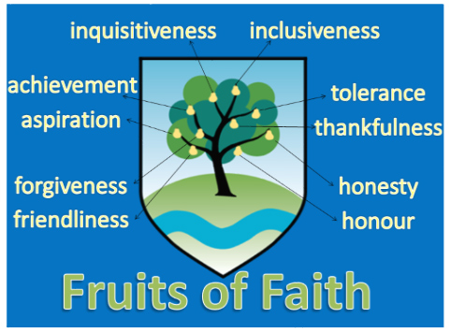 | What fruits of faith have you used: | What fruits of faith have you used:
E = 0-6 D = 7-13 S = 14-19 M = 20-24

